
Viewed by:
Philippe POHER
Tel.: +33 (0)2 99 27 92 92
E-mail: philippe.poher@iWedia.com

Written by:
Guy SCRUIGNEC
Tel.: +33 (0)2 99 27 92 92
E-mail: guy.scruigne@iWedia.com
IWEDIA

TDAL_ANA_INPUT Technical Specifications

V1.3

Approved by:
Thierry GARNIER
Tel.: +33 (0)2 99 27 92 92
E-mail: thierry.garnier@iWedia.com

SUMMARY
1 INTRODUCTION 3
1.1 REFERENCE DOCUMENTS 3
1.2 DEFINITIONS, ACRONYMS AND ABBREVIATIONS 3
1.3 OVERVIEW 3
2 TDAL_ANA_INPUT DESCRIPTION 4
2.1 DESCRIPTION 4
2.1.1 General 4
2.1.2 Input object 5
2.1.3 Interactions with TDAL_ANA_VID and TDAL_ANA_AUD module 5
2.2 STATIC DIAGRAM 6
2.2.1 Supported features 6
2.2.2 Unsupported features 6
2.2.3 API functions description 7
2.2.4 Interface definition 7
2.2.5 External dependencies list 8
2.2.6 Memory consumption and performance 8
3 TDAL_ANA_INPUT DYNAMIC BEHAVIOUR 9
3.1 Several audio video input selection 9
4 TDAL_ANA_INPUT API SPECIFICATION 10
4.1 MACRO/DEFINE/ENUM/TYPEDEF/STRUCTURE/UNION DEFINITIONS 10
4.1.1 Define Definitions 10
4.1.2 Enum Definitions 10
4.1.3 Typedef definitions 11
4.1.4 Structure Definitions 11
4.1.5 Union Definitions 12
4.2 API FUNCTIONS 13
4.2.1 Generic API 13
4.2.2 Management API 16
5 TDAL_ANA_INPUT EXTERNAL DEPENDENCIES 18

INTRODUCTION

REFERENCE DOCUMENTS
The following documents were used to write this specification:

Document | Version
[TDAL_ANA_VID] Interface Requirement Specification TV Connected - TDAL_ANA_VID | V1.3
[TDAL_ANA_AUD] Interface Requirement Specification TV Connected - TDAL_ANA_AUD | V1.1

DEFINITIONS, ACRONYMS AND ABBREVIATIONS
ADC | Analog to Digital Converter
AV | Audio Video
CVBS | Composite Video, Blanking, Synchronization: (Video format where luminance, chrominance, blanking, and synchronization are integrated in one signal)
COMP | Component Video Input (Video format where color information is transmitted in 3 different signals)
LR | Left Right
YC | Video format where color information is transmitted in a luminance (Y) and one chrominance (C) signal

OVERVIEW
The purpose of this document is to specify the abstraction layer targeted to manage the TV analog inputs. This layer acts as a source selector for analog video/audio pins.

TDAL_ANA_INPUT DESCRIPTION

DESCRIPTION

General

The function of the TDAL_ANA_INPUT is to select a specific video/audio input source to be routed thus acting as a sources selector.
A schematic representation of the data flow through the TDAL_ANA_INPUT is described in the following figure.
TDAL_ANA_INPUT can have several multiplexers:
- Video Multiplexer: This can take either CVBS or YC or COMP as input and give one output to the video decoder (either composite or component).
- Audio Multiplexer: This can take baseband LR input and outputs digitized audio. It is used to select the audio from AV extensions.

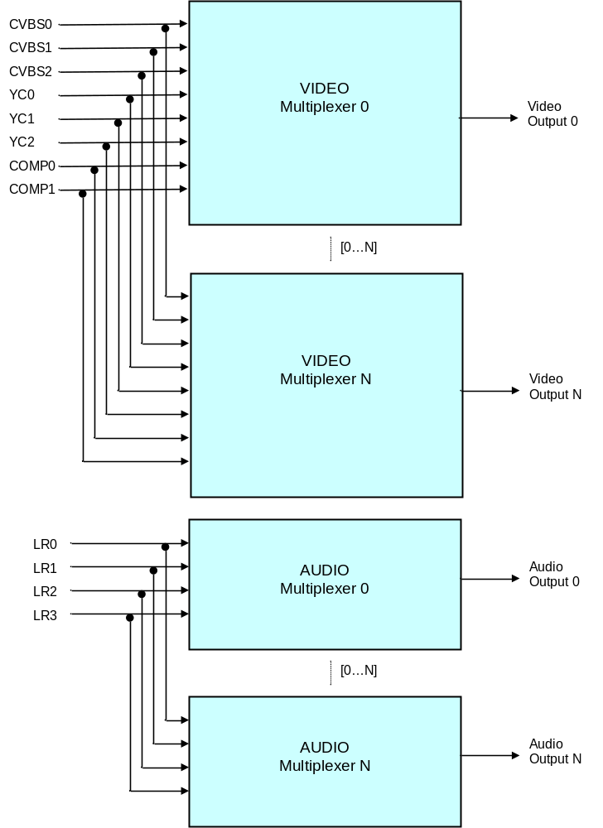

Input object
The concept of TDAL_ANA_INPUT object is used. A TDAL_ANA_INPUT object represents different types of hardware piece (video input, audio input, multiplexer…) instance. This instance is also classified as a video or audio object.

Each input objects can be connected or not to several multiplexer of the same class. At a minimum, one input object has to be connected to one multiplexer.

Interactions with TDAL_ANA_VID and TDAL_ANA_AUD module
TDAL_ANA_INPUT needs an access to the decoder of TDAL_ANA_VID/TDAL_ANA_AUD to indicate in which video/audio decoder, the video/audio input chosen result must be sent.
For that purpose and to have a complete independence between the TDAL_ANA_VID, TDAL_ANA_AUD, TDAL_ANA_INPUT and other TDAL APIs, the notion of input handle is used. The input handle is an unique opaque value that is used as accessor to a specific input muliplexer. This handle is used transversely between the different TDAL modules in order to authorize a TDAL module to access the low level driver that manages the decoders.
See [TDAL_ANA_VID] and [TDAL_ANA_AUD] for more details.

STATIC DIAGRAM
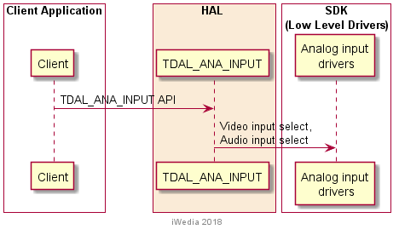

Supported features

None.

Unsupported features
None.

API functions description

Generic part

The generic interface allows clients to control the TDAL_ANA_INPUT module.
This interface is used with the following functions:
- TDAL_ANA_INPUT_Init(-) in order to initialize the TDAL_ANA_INPUT module.
- TDAL_ANA_INPUT_Term(-) in order to terminate the TDAL_ANA_INPUT module.
- TDAL_ANA_INPUT_CapabilityGet(-) in order to get the capabilities of the current implementation of TDAL_ANA_INPUT module.
- TDAL_ANA_INPUT_MuxCapabilityGet(-) in order to get the capabilities of the requested multiplexer.
- TDAL_ANA_INPUT_APIRevisionGet(-) in order to retrieve the version of the TDAL_ANA_INPUT API.
- TDAL_ANA_INPUT_PlatformRevisionGet(-) in order to retrieve the version of the TDAL_ANA_INPUT platform implementation.

Management part
This interface part allows clients to configure the TDAL_ANA_INPUT module.
This interface is used with the following functions:
- TDAL_ANA_INPUT_VideoInputSelect(-) in order to select the setting of the video multiplexer.
- TDAL_ANA_INPUT_HandleGet(-) in order to to get an opaque unique handle on a stream.
- TDAL_ANA_INPUT_AudioInputSeletect(-) in order to select the setting of the audio multiplexer.

Interface definition

Type Specifications

The object identifier tTDAL_ANA_INPUT_Object is the way used by an application to access in a single way a specific TDAL_ANA_INPUT object.
Some macros are defined to get some information on an object:
- mTDAL_ANA_INPUT_GetObjectClass(object) to get the class (video or audio) of a TDAL_ANA_INPUT object.
- mTDAL_ANA_INPUT_GetObjectType(object) to get the type (CVBS, YC, COMP, LR, MUX) of a TDAL_ANA_INPUT object.
- mTDAL_ANA_INPUT_GetObjectInstance(object) to get the instance (0,…,n) of a TDAL_ANA_INPUT object.
- mTDAL_ANA_INPUT_GetObjectId(class, type , instance) to get the object from its class, type and instance.

Below are the other type definitions;
- tTDAL_ANA_INPUT_Error is defined to identify an error of the TDAL_ANA_INPUT interface.
- tTDAL_ANA_INPUT_Capability is defined to get the capabilities of the TDAL_ANA_INPUT current implementation.
- tTDAL_ANA_INPUT_MuxCapability is defined to get the capabilities of the requested multiplexer.

External dependencies list
None.

Memory consumption and performance
The TDAL_ANA_INPUT client must allocate the pointer parameters when needed. It can release the pointer when the TDAL_ANA_INPUT called function has returned.

TDAL_ANA_INPUT DYNAMIC BEHAVIOUR

Several audio video input selection
TDAL client needs:
- To know the number of input object instance available.
- To select 1st audio/video input choice CVBS0 + LR0
- To select 2nd audio/video input choice COMP0 + LR1
- To select 3rd audio/video input choice CVBS0 + LR0 again.

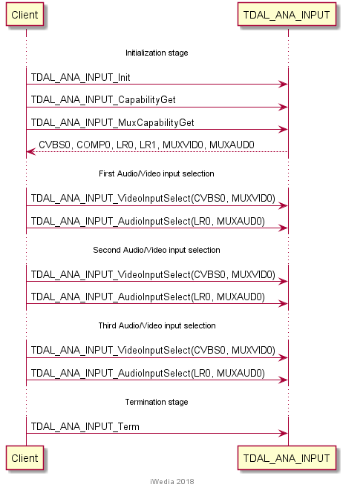

TDAL_ANA_INPUT API SPECIFICATION

MACRO/DEFINE/ENUM/TYPEDEF/STRUCTURE/UNION DEFINITIONS

Define Definitions

kTDAL_ANA_INPUT_MASK_CLASS
This constant is used to define the class mask of an input object.
#define kTDAL_ANA_INPUT_MASK_CLASS 0xff0000

kTDAL_ANA_INPUT_MASK_TYPE
This constant is used to define the type mask of an input object.
#define kTDAL_ANA_INPUT_MASK_TYPE 0x00ff00

kTDAL_ANA_INPUT_MASK_INSTANCE
This constant is used to define the instance mask of an input object.
#define kTDAL_ANA_INPUT_MASK_INSTANCE 0x0000ff

kTDAL_ANA_INPUT_NO_OBJECT
This constant is used to define the object invalid value.
#define kTDAL_ANA_INPUT_NO_OBJECT 0xFFFFFF

mTDAL_ANA_INPUT_GetObjectId
This macro is used to get the object from its class, type and instance.
#define mTDAL_ANA_INPUT_GetObjectId( class , type , instance ) \
(class << 16) + (type << 8) + instance

mTDAL_ANA_INPUT_GetObjectClass
This macro is used to get the class (video or audio) of a TDAL_ANA_INPUT object.
#define mTDAL_ANA_INPUT_GetObjectClass( object ) \
(object & kTDAL_ANA_INPUT_MASK_CLASS) >> 16

mTDAL_ANA_INPUT_GetObjectType
This macro is used to get the type (CVBS, YC, COMP, LR, SIF) of a TDAL_ANA_INPUT object.
#define mTDAL_ANA_INPUT_GetObjectType( object ) \
(object & kTDAL_ANA_INPUT_MASK_TYPE) >> 8

mTDAL_ANA_INPUT_GetObjectInstance
This macro is used to get the instance (0,…,n) of a TDAL_ANA_INPUT object
#define mTDAL_ANA_INPUT_GetObjectInstance( object ) \
(object & kTDAL_ANA_INPUT_MASK_INSTANCE)

Enum Definitions

Object class
An enumeration of the different object class.
enum {
eTDAL_ANA_INPUT_CLASS_VIDEO = 0 ,
eTDAL_ANA_INPUT_CLASS_AUDIO
};

Object type
An enumeration of the different object type.
enum {
eTDAL_ANA_INPUT_TYPE_MUX = 0, /* Muliplexer object type */
eTDAL_ANA_INPUT_TYPE_CVBS, /* CVBS video input object type */
eTDAL_ANA_INPUT_TYPE_YC, /* YC video input object type */
eTDAL_ANA_INPUT_TYPE_COMP, /* Component video input object type */
eTDAL_ANA_INPUT_TYPE_LR /* LR baseband audio input object type */
};

tTDAL_ANA_INPUT_Error
An enumeration of the different possible errors generated by TDAL_ANA_INPUT module.
typedef enum
{
eTDAL_ANA_INPUT_NO_ERROR, /* No Error returned */
eTDAL_ANA_INPUT_NOT_INIT_ERROR, /* TDAL_ANA_INPUT has not been initialised */
eTDAL_ANA_INPUT_ALREADY_INIT_ERROR, /* TDAL_ANA_INPUT already initialised */
eTDAL_ANA_INPUT_BAD_ARG_ERROR, /* Bad parameter given to the function */
eTDAL_ANA_INPUT_DRIVER_ERROR, /* Low level driver returns an error */
eTDAL_ANA_INPUT_NO_MEMORY_ERROR, /* Not enough memory to perform action*/
eTDAL_ANA_INPUT_NOT_AVAILABLE_ERROR /* Feature not available*/
}tTDAL_ANA_INPUT_Error;

Typedef definitions

tTDAL_ANA_INPUT_Object
This typedef defines an input object.
typedef uint32_t tTDAL_ANA_INPUT_Object;

Structure Definitions

tTDAL_ANA_INPUT_Capability
Description:

This structure defines the capabilities of a TDAL_ANA_INPUT implementation.

Definition:

typedef struct TDAL_ANA_INPUT_Capability_s
{
uint8_t nbInput;
tTDAL_ANA_INPUT_Object *InputArray;
uint8_t nbMux;
tTDAL_ANA_INPUT_Object *MuxArray;
} tTDAL_ANA_INPUT_Capability;

Elements:

Field | Type | Description
nbInput | uint8_t | Number of available input objects
InputArray | tTDAL_ANA_INPUT_Object * | Pointer to array of the available input objects. The number of element in the array is nbInput value.
nbMux | uint8_t | Number of available multiplexer objects
MuxArray | tTDAL_ANA_INPUT_Object * | Pointer to array of the available multiplexer objects. The number of element in the array is nbMux value.

Comments:

The number of input objects are the all available audio/video inputs of the platform.

See Also:
TDAL_ANA_INPUT_CapabilityGet(-)

tTDAL_ANA_INPUT_MuxCapability
Description:

This structure defines the capabilities of a specifi multiplexer.

Definition:

typedef struct TDAL_ANA_INPUT_MuxCapability_s
{
uint8_t nbInput;
tTDAL_ANA_INPUT_Object *InputArray;
} tTDAL_ANA_INPUT_MuxCapability;

Elements:

Field | Type | Description
nbInput | uint8_t | Number of available input objects
InputArray | tTDAL_ANA_INPUT_Object * | Pointer to array of the available input objects. The number of element in the array is nbInput value.

Comments:

The number of input objects are the available audio or video inputs of a specific multiplexer.

See Also:
TDAL_ANA_INPUT_MuxCapabilityGet(-).

Union Definitions
None.

API FUNCTIONS

Generic API

TDAL_ANA_INPUT_Init(-)
Prototype:

tTDAL_ANA_INPUT_Error TDAL_ANA_INPUT_Init (void);

Description:

This function initialises the TDAL_ANA_INPUT module.

Return value:

It returns eTDAL_ANA_INPUT_NO_ERROR if initialization succeed.
It could be eTDAL_ANA_INPUT_ALREADY_INIT_ERROR, eTDAL_ANA_INPUT_DRIVER_ERROR or eTDAL_ANA_INPUT_NO_MEMORY_ERROR otherwise.

Parameters:

None.

Comments:

This function must be called before any other functions of the TDAL_ANA_INPUT API.

See Also:
TDAL_ANA_INPUT_Term(-)

TDAL_ANA_INPUT_Term(-)
Prototype:

tTDAL_ANA_INPUT_Error TDAL_ANA_INPUT_Term (void);

Description:

This function terminates the TDAL_ANA_INPUT module.

Return value:

It returns eTDAL_ANA_INPUT_NO_ERROR if termination succeed.
It could be eTDAL_ANA_INPUT_NOT_INIT_ERROR, eTDAL_ANA_INPUT_DRIVER_ERROR otherwise.

Parameters:

None.

Comments:

Any function of TDAL_ANA_INPUT API should not be called after TDAL_ANA_INPUT_Term(-) call.

See Also:
TDAL_ANA_INPUT_Init(-)

TDAL_ANA_INPUT_CapabilityGet(-)
Prototype:

tTDAL_ANA_INPUT_Error TDAL_ANA_INPUT_CapabilityGet
(
tTDAL_ANA_INPUT_Capability *pstCapability
);

Description:

This function retrieves the capabilities of the TDAL_ANA_INPUT current implementation.

Return value:

It returns eTDAL_ANA_INPUT_NO_ERROR if retrieve of capabilities succeed.
It could be eTDAL_ANA_INPUT_NOT_INIT_ERROR, eTDAL_ANA_INPUT_DRIVER_ERROR, eTDAL_ANA_INPUT_BAD_ARG_ERROR otherwise.

Parameters:

Parameter | Type | Dir | Description
pstCapability | tTDAL_ANA_INPUT_Capabilities * | In/out | In: Allocated capability structure pointer.  Out: Structure filled with capabilities of the implementation of the TDAL_ANA_INPUT module.

Comments:

This function can be called at any time the TDAL_ANA_INPUT has been initialised with TDAL_ANA_INPUT_Init(-) but not after the termination with TDAL_ANA_INPUT_Term(-).

See Also:
tTDAL_ANA_INPUT_Capability

TDAL_ANA_INPUT_MuxCapabilityGet(-)
Prototype:

tTDAL_ANA_INPUT_Error TDAL_ANA_INPUT_MuxCapabilityGet
(
tTDAL_ANA_INPUT_Object MuxId
tTDAL_ANA_INPUT_MuxCapability *pstMuxCapability
);

Description:

This function retrieves the capabilities of the requested multiplexer.

Return value:

It returns eTDAL_ANA_INPUT_NO_ERROR if retrieve of capabilities succeed.
It could be eTDAL_ANA_INPUT_NOT_INIT_ERROR, eTDAL_ANA_INPUT_DRIVER_ERROR, eTDAL_ANA_INPUT_BAD_ARG_ERROR otherwise.

Parameters:

Parameter | Type | Dir | Description
pstMuxCapability | tTDAL_ANA_INPUT_MuxCapabilities * | In/out | In: Allocated capability structure pointer.  Out: Structure filled with capabilities of the multiplexer.

Comments:

This function can be called at any time the TDAL_ANA_INPUT has been initialised with TDAL_ANA_INPUT_Init(-) but not after the termination with TDAL_ANA_INPUT_Term(-).

See Also:
tTDAL_ANA_INPUT_MuxCapability.

TDAL_ANA_INPUT_APIRevisionGet(-)
Prototype:

const char *TDAL_ANA_INPUT_APIRevisionGet(void);

Description:

This function retrieves the API revision.

Return value:

A string containing the revision of the TDAL_ANA_INPUT API.

Parameters:

None.

Comments:

This function can be called at any time.

See Also:

TDAL_ANA_INPUT_PlatformRevisionGet(-)
Prototype:

const char *TDAL_ANA_INPUT_PlatformRevisionGet(void);

Description:

This function retrieves the platform implementation revision.

Return value:

A string containing the revision of the TDAL_ANA_INPUT implementation on a platform.

Parameters:

None.

Comments:

This function can be called at any time.

See Also:

Management API

TDAL_ANA_INPUT_VideoInputSelect(-)
Prototype:

tTDAL_ANA_INPUT_Error TDAL_ANA_INPUT_VideoInputSelect
(
tTDAL_ANA_INPUT_Object InputId,
tTDAL_ANA_INPUT_Object MuxId
);

Description:

This function selects the input setting of the video multiplexer.

Return value:

It returns eTDAL_ANA_INPUT_NO_ERROR if s succeed.
It could be eTDAL_ANA_INPUT_NOT_INIT_ERROR, eTDAL_ANA_INPUT_DRIVER_ERROR, eTDAL_ANA_INPUT_BAD_ARG_ERROR otherwise.

Parameters:

Parameter | Type | Dir | Description
InputId | tTDAL_ANA_INPUT_Object | In | Video class input object identifier
MuxId | tTDAL_ANA_INPUT_Object | In | Video class multiplexer object identifier

Comments:

This function can be called at any time the TDAL_ANA_INPUT has been initialised with TDAL_ANA_INPUT_Init(-) but not after the termination with TDAL_ANA_INPUT_Term(-).

See Also:
tTDAL_ANA_INPUT_Object

TDAL_ANA_INPUT_HandleGet(-)
Prototype:

tTDAL_ANA_INPUT_Error TDAL_ANA_INPUT_HandleGet
(
tTDAL_ANA_INPUT_Object MuxId,
void *pHandle
);

Description:

This function is used to get an opaque unique handle on the input mulitplexer.

Return value:

It returns eTDAL_ANA_INPUT_NO_ERROR if s succeed.
It could be eTDAL_ANA_INPUT_NOT_INIT_ERROR, eTDAL_ANA_INPUT_DRIVER_ERROR, eTDAL_ANA_INPUT_BAD_ARG_ERROR otherwise.

Parameters:

Parameter | Type | Dir | Description
MuxId | tTDAL_ANA_INPUT_Object | In | Multiplexer object identifier
pHandle | void * | In/Out | In: pointer to a layer handle.  Out: unique input handle.

Comments:
The opaque handle is typically used in other TDAL modules which needs to link information to the input (analog video decoder, …). For more details, see chapter “Interactions with TDAL_ANA_VID and TDAL_ANA_AUD module”.

See Also:

tTDAL_ANA_INPUT_Object.

TDAL_ANA_INPUT_AudioInputSelect(-)
Prototype:

tTDAL_ANA_INPUT_Error TDAL_ANA_INPUT_AudioInputSelect
(
tTDAL_ANA_INPUT_Object InputId,
tTDAL_ANA_INPUT_Object MuxId
);

Description:

This function selects the input setting of the audio multiplexer.

Return value:

It returns eTDAL_ANA_INPUT_NO_ERROR if s succeed.
It could be eTDAL_ANA_INPUT_NOT_INIT_ERROR, eTDAL_ANA_INPUT_DRIVER_ERROR, eTDAL_ANA_INPUT_BAD_ARG_ERROR otherwise.

Parameters:

Parameter | Type | Dir | Description
InputId | tTDAL_ANA_INPUT_Object | In | Audio class and LR type input object identifier
MuxId | tTDAL_ANA_INPUT_Object | In | Audio class multiplexer object identifier

Comments:

This function can be called at any time the TDAL_ANA_INPUT has been initialised with TDAL_ANA_INPUT_Init(-) but not after the termination with TDAL_ANA_INPUT_Term(-).

See Also:
tTDAL_ANA_INPUT_Object

TDAL_ANA_INPUT EXTERNAL DEPENDENCIES
None.

